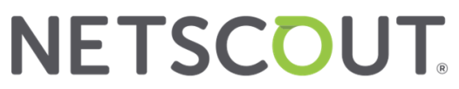

NETSCOUT to Participate in 9th Annual B. Riley Securities Consumer & TMT Conference

WESTFORD, Mass. – NETSCOUT SYSTEMS, INC. (NASDAQ: NTCT), a leading provider of network observability, AIOps, carrier service assurance, cybersecurity, and DDoS attack protection, today announced that the Company will participate in the 9th Annual B. Riley Securities Consumer & TMT Conference in New York City on September 10, 2026.

CFO Tony Piazza, CTO Representative Dr. Vikram Saksena, and VP Corporate Finance Scott Dressel will be available to take meetings with investors.

About NETSCOUT
NETSCOUT SYSTEMS, INC. (NASDAQ: NTCT) protects the connected world from cyberattacks and performance and availability disruptions through its unique visibility platform and solutions powered by its pioneering deep packet inspection at scale technology. As a leading provider of network observability, AIOps, carrier service assurance, cybersecurity, and Distributed Denial-of-Service (DDoS) attack protection solutions, NETSCOUT serves the world’s largest enterprises, service providers, and public sector organizations. Learn more at www.netscout.com or follow @NETSCOUT on LinkedIn, X, or Facebook.

©2026 NETSCOUT SYSTEMS, INC. All rights reserved. NETSCOUT and the NETSCOUT logo are registered trademarks or trademarks of NETSCOUT SYSTEMS, INC., and/or its subsidiaries and/or affiliates in the USA and/or other countries.

Contacts:
Investors Media
Scott Dressel Chris Lucas
VP, Corporate Finance AVP, Marketing & Corporate Communications
978-614-4000 978-614-4124
IR@netscout.com Chris.Lucas@netscout.com

