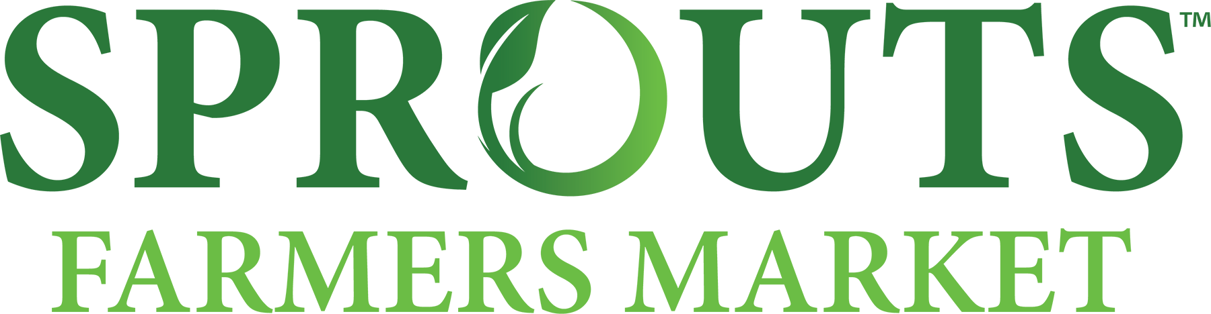
_____________________________________________________________________________________
Investor Contact: Media Contact:
Susannah Livingston media@sprouts.com
(602) 682-1584
susannahlivingston@sprouts.com

Sprouts Farmers Market to Report Third Quarter 2026 Earnings on October 28, 2026
PHOENIX, Sept 30, 2026 (Business Wire) – Sprouts Farmers Market, Inc. (Nasdaq: SFM) today announced it will issue financial results for the third quarter ended September 27, 2026, after the market closes on Wednesday, October 28, 2026. Following the release, Sprouts’ management will conduct a conference call at 5:00 p.m. ET to discuss the results for the quarter.

A webcast of the conference call will be available at investors.sprouts.com. Participants should register on the website approximately ten minutes prior to the start of the webcast.

A webcast replay will be available at approximately 8:00 p.m. ET on October 28, 2026. This can be accessed with the following link.

About Sprouts Farmers Market
Sprouts Farmers Market is one of the largest and fastest growing specialty retailers of fresh, natural and organic food in the United States. Sprouts helps people live and eat better with fresh produce at the heart of the store and delicious discoveries for every dietary lifestyle. Always foraging for what’s fresh and innovative, Sprouts offers a carefully curated assortment of products that inspire wellness naturally, including organic, gluten-free, plant-based and non-GMO favorites. Headquartered in Phoenix, AZ, Sprouts employs approximately 36,000 team members and operates more than 500 stores in 25 states nationwide. To learn more about Sprouts and the role it plays in its communities, visit sprouts.com/about/.

