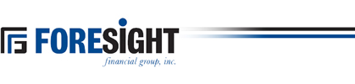

FORESIGHT FINANCIAL GROUP, INC.
809 Cannell Puri Court
Winnebago, IL 61088

FORESIGHT FINANCIAL GROUP ANNOUNCES QUARTERLY DIVIDEND

Winnebago, IL, July 30, 2025

The Board of Directors of Foresight Financial Group, Inc., has declared a quarterly cash dividend of $0.20 cents per share.

The dividend is payable to shareholders of record on August 11, 2025 and is payable August 18, 2025.

Foresight Financial Group, Inc. (OTCQX: FGFH) is headquartered in Northwestern Illinois and has assets totaling $1.61 billion as of June 30, 2025. Foresight’s community banks include Northwest Bank of Rockford, State Bank, Freeport, State Bank of Davis, German-American State Bank, German Valley, Lena State Bank and State Bank of Herscher.

Foresight common stock is listed on the “OTCQX” Marketplace under the trading symbol “FGFH.”

