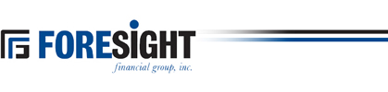

FORESIGHT FINANCIAL GROUP, INC.
809 Cannell Puri Court
Winnebago, IL 61088

FORESIGHT FINANCIAL GROUP ANNOUNCES QUARTERLY DIVIDEND

Winnebago, IL, October 29, 2025

The Board of Directors of Foresight Financial Group, Inc., has declared a quarterly cash dividend of $0.20 cents per share.

The dividend is payable to shareholders of record on November 12, 2025 and is payable November 19, 2025.

Foresight Financial Group, Inc. is a bank holding company headquartered in Winnebago County, Illinois and is the parent company of Foresight Bank, which operates in Northern Illinois under its divisional names Northwest Bank of Rockford, State Bank in Freeport, State Bank of Davis, German American State Bank in German Valley, Winnebago and Pecatonica, Lena State Bank, and the State Bank of Herscher. Foresight’s common stock is traded on the “OTCQX” market under the trading symbol FGFH.

Foresight common stock is listed on the “OTCQX” Marketplace under the trading symbol “FGFH.”

